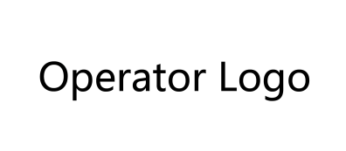

**API Document for Viettel Home Wi-Fi**

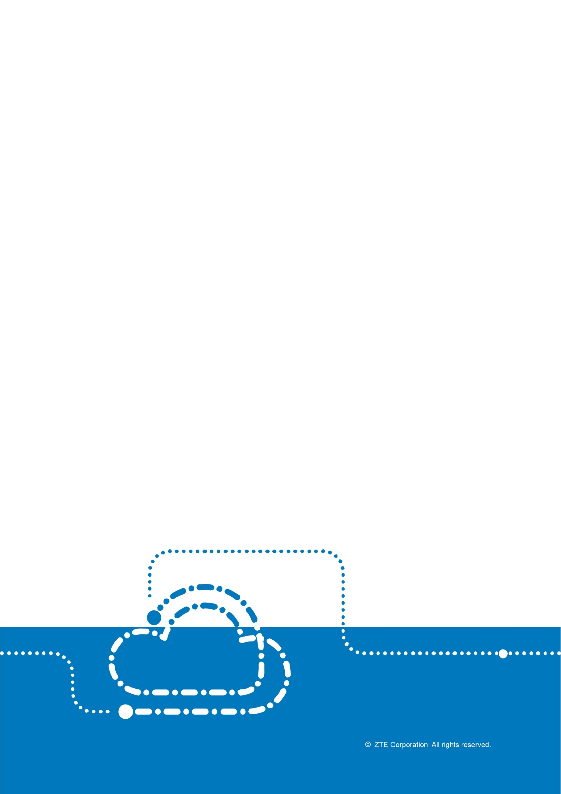

API Document for Viettel Home Wi-Fi

|  |  |  |  |  |
| --- | --- | --- | --- | --- |
| **Version** | **Date** | **Author** | **Reviewer** | **Notes** |
| V1.0 | 2021/05/07 | ZTE |  | Not open to the third party |
| V2.0 | 2021/08/27 | ZTE |  |  |

© 2021 ZTE Corporation. All rights reserved.

ZTE CONFIDENTIAL: This document contains proprietary information of ZTE and is not to be disclosed or used without the prior written permission of ZTE.

Due to update and improvement of ZTE products and technologies, information in this document is subjected to change without notice.

TABLE OF CONTENTS

1 Interface Data Format 3

1.1 Return JSON 3

1.2 Example 4

1.2.1 Success 4

1.2.2 Failure 4

2 Interface Verification 4

3 Interface Description 5

3.1 Obtaining Device Information 5

3.2 Customer account reset (Unbinding Devices) 7

3.3 Mesh Network Status Query 8

4 Table of Error Code 9

# Interface Data Format

## Return Format

{

"code": 0,

"message": "",

"data": ""

}

|  |  |  |  |  |
| --- | --- | --- | --- | --- |
|  | Description | Example | Type | Remark |
| code | Status code | 0 | int | 0: Success;  others: Failure. |
| message | Error message | success | String | when code=0,  message=”success”;  otherwise,  message is error description |
| data | Actually Returned Data | “” | String | when code = 0;  data is actually returned data;  otherwise,  data=”” |

## Example

### Success

{

"code": 0,

"message": "success",

"data": " Json character string or other return, depending on the actual interface "

}

### Failure

{

"code": Error Code,

"message": " Error Message",

"data": ""

}

# Interface Verification

For the sake of security, security verification must be performed on the interface.

Parameters must be added for all interfaces.

|  |  |  |  |  |
| --- | --- | --- | --- | --- |
|  | Description | Example | Type | Remarks |
| _ak | Access Key Id | viettel | string | fixed |
| _ts | Timestamp, seconds | 1612681743 | Long | Acts as a random value to prevent data from being tampered with. |
| _signature | Signature |  | string | The signature algorithm is as follows: |

The signature algorithm is as follows:

_signature = hmacSha1(sk, uppercaseOfHttpMethod + pathString);

sk:4cd4bc99e2394fa4a81ce2d47c1e4fe5fe24f2fbadf744b196e1ab0e91fa00e74d864f1397b942afb859a165847f4f9a04dae54eac7b48f296f6f836cde5289e

uppercaseOfHttpMethod : The uppercase of HTTP method. For example: GET, POST

pathString :path.substring(0, path.indexOf("&_signature")) . For example: If request url=”https://nbi.viettelhomewifi.com/viettel/north/devinfo?_ak=viettel&_ts=1612681743&SN=ZTEEH7VL4400010&_signature=......”, then pathString is “/viettel/north/devinfo?_ak=viettel&_ts=1612681743&SN=ZTEEH7VL4400010”

# Interface Description

## Obtaining Device Information

URL：/viettel/north/devinfo

Method: Get

Parameter:

|  |  |  |  |  |
| --- | --- | --- | --- | --- |
|  | Description | Example | Type | Remarks |
| SN | Device serial number | ZTEEH7VL4400010 | string | Required |

Response：

{

"code": 0,

"message": "success",

"data": "{\"BoundAccount\":\"02552870518\",\"ConfigurationVersion\":\"V9.0.0-VTEL\",\"FirmwareVersion\":\"V9.0.0C3_CLO-o\",\"MAC\":\"00:19:c6:51:29:24\",\"MeshStatus\":\"controller\",\"Model\":\"H196A V9\",\"RegistrationTime\":1608002288439,\"SN\":\"ZTEEH7VL4400010\",\"lastOnlineTime\":1608608839266,\"onlineStatus\":1,\"WanMode\":\"DHCP\",\"Rssi\":60}"

}

Data is the character string of JSON.

|  |  |  |  |  |
| --- | --- | --- | --- | --- |
|  | Description | Example | Type | Remarks |
| SN | Device serial number | ZTEEH7VL4400010 | int |  |
| MAC | Device MAC address | 00:19:c6:51:29:24 | string |  |
| Model | Model of device | H196A V9 | string |  |
| FirmwareVersion | Firmware of device | V9.0.0C3_CLO-o | string |  |
| ConfigurationVersion | Configuration version of device | V9.0.0-VTEL | string |  |
| RegistrationTime | Time of registration | 1608002288439 | long |  |
| BoundAccount | Broadband account | 02552870518 | string |  |
| OnlineStatus | Online status | 1 | int |  |
| LastOnlieTime | Last online time | 1608608839266 | long |  |
| MeshStatus | Mesh status | controller | string |  |
| WanMode | Wan mode | DHCP | String |  |
| Rssi | rssi | -65 | int | If the Agent is wired access, the RSSI will return 100; if the AP is the Controller, the RSSI will return 200; the rest will be returned according to actual values |

## Customer account reset (Unbinding Devices)

URL：/viettel/north/unbind

Method: Get

Parameter:

|  |  |  |  |  |
| --- | --- | --- | --- | --- |
|  | Description | Example | Type | Remarks |
| SN | Device serial number | ZTEEH7VL4400010 | string | Required |

Response：

{

"code": 0,

"message": "success",

"data": ""

}

## Mesh Network Status Query

URL：/viettel/north/mesh/check

Method: Get

Parameter:

|  |  |  |  |  |
| --- | --- | --- | --- | --- |
|  | Description | Example | Type | Remarks |
| SNList | Device serial number list, separated by commas | ZTEEH7VL4400010,ZTEEH7VL9G00007,ZTEEH7VL4400008 | string | Required |

Response：

{

"code": 0,

"message": "success",

"data": "{\"isSameMeshNetwork\":\"true\",\"isRssiExceedLimit\":\"true\"}

}

|  |  |  |  |  |
| --- | --- | --- | --- | --- |
|  | Description | Example | Type | Remarks |
| isSameMeshNetwork | Whether all devices are in the same mesh network | true | String | It will return false if offline devices exist |
| isRssiExceedLimit | Whether the rssi of all devices is greater than the set value | true | String | 1.Only consider the rssi value of online devices.  2.The default value is -65dBm  3.If the Agent is wired access, the RSSI is calculated as 100; if the AP is the Controller, the RSSI is calculated as 200; |

# Table of Error Code

|  |  |  |
| --- | --- | --- |
| Code | Message | Description |
| -32704 | Device not bound | The device is not bound and cannot be unbound. |
| -32098 | "The device does not exist:" + No device parameters | Input parameter. There is no device in the database. |
| -32700 | Invalid parameter | The input parameter is invalid (missing or incorrect parameter type). |
| -32603 | Server internal error | System error |
| 1001 | Abnormal data | The user bound to the device does not exist. |
| 2202 | Abnormal data | The binding relationship is changed. |
| 9300 | The server ID failed to be authenticated. | AK, SK verification failed. |